# **Servo Motor Interfacing with 8051**

# **Servo Motor:**

Servo motors are self-contained mechanical devices that are used to control the machines with great precision. These are found in many applications from toys to industrial automation.  There is various kind of motor, but servo motors are especially designed for specific angular position to control the machines.

Servo motors are most commonly used in closed-loop systems where the precision of the position of the shaft is a must required quality. Usually the servo motor is used to control the angular motion among from 0° to 180° and 0° to 90°. The [servo motor working principle](https://www.elprocus.com/servo-motor/) based on the PWM ([pulse width modulation](https://www.elprocus.com/pulse-width-modulation-pwm/)) pulses.

## ****Components of a Servo Motor:****

## 

Broadly, a servo motor consists of:

**Electric Motor:** A motor is a device that converts electrical energy into mechanical energy; it’s a rotatory element.

**Control system:**  A closed-loop system that controls the position of the shaft depending on the control signal.

**Gears System:** It consists of an arrangement of gears in such a way that one can increase or decrease the speed and torque of the motor.

**Potentiometer:** It is connected to the central shaft, and helps the control system to monitor the angle in which the motor’s shaft is positioned. 

# **Working Principle of Servo Motors:**

 Servo motor works on PWM (Pulse width modulation) principal, means its angle of rotation is controlled by the duration of applied pulse to its Control PIN. Basically servo motor is made up of DC motor which is controlled by a variable resistor (potentiometer) and some gears. High speed force of DC motor is converted into torque by Gears. Potentiometer is connected to the output shaft of the Servo, to calculate the angle and stop the DC motor on required angle.

Servo motor can be rotated from 0 to 180 degree, but it can go up to 210 degree, depending on the manufacturering. This degree of rotation can be controlled by applying a LOGIC level 1 pulse for a duration between 1ms to 2ms. A 1 ms can rotate servo to 0 degree, 1.5ms can rotate to 90 degree and 2 ms pulse can rotate it to 180 degree. Duration between 1 to 2 ms can rotate Servo motor to any angle between 0 to 180 degree.

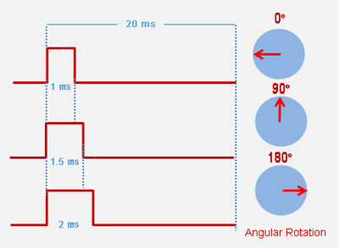

## ****Interface A Servo Motor to 8051 microcontroller**** :

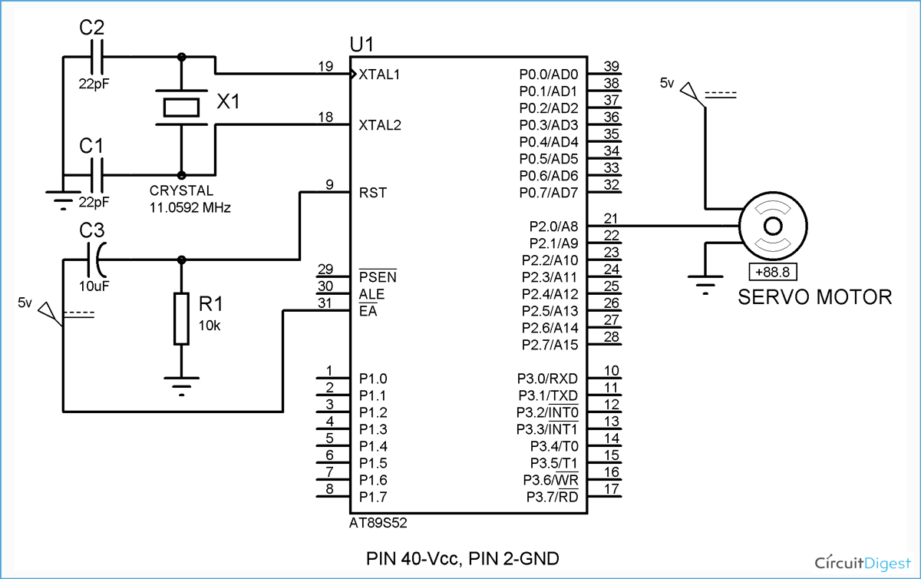

Here the servo motor interfacing with 8051 microcontroller, it has 3 wires,one wire connected to the ground pin and the motor get the power from the other wire. The remining wire is used to control of servo motor connected port 0 (pin 21) of 8051 microcontroller.

The 11.0592MHz crystal oscillator a 12 MHz oscillator between pin 18 and 19 and it is used to provide the clock pulsed to the microcontroller and 22pf ceramic capacitors used to stabilize the operation of crystal.

Two capacitors of 22pF are connected, with one terminal on either side of the oscillator and the other terminal to ground, as shown below. Set Pin 31, i.e., EA pin to HIGH by connecting it to the +5V DC source.

the RESET circuit, connect Pin 9 (RST) to +5V through a capacitor of 10µF and connect the same pin to +0V (GND) through a 10kΩ resistor or a potentiometer. This 10KΩ and 10uf capacitor is used to provide the power on reset to the microcontroller.

# **Interfacing Stepper Motor with 8051 Microcontroller:**

* A motor, in general, is a device that converts electrical energy into mechanical energy.
* As the name suggests, a stepper motor is a device that does the same task as above but, in steps.
* It is a brushless, synchronous electric motor that can divide a complete rotation into a number of steps. Stepper motors generally have a permanent magnet shaft (rotor), and it is surrounded by a stator.
* The best feature of this type of motor is that the motor’s angular position can be accurately controlled without any feedback mechanism, as long as the motor is not oversized.
* Therefore, it works in a simple accurate open-loop system, where the output is directly dependent on the input.
* A stepper motor rotates at small angles to complete 360 degrees rotation, these small angles are called steps, hence the name Stepper Motor. Typically, a stepper motor consists of 200 steps.
* 200 Steps = 360 degrees  
  1 Step = ‘x’ degrees  
  x = 360 / 200 = 1.8 degree
* Therefore, every step is 1.8 degrees.

The high and low pulses are provided to the stator coil of the stepper motor.

Here we’re using a 4-coil stator. The angle of each step is decided by the steps in the rotor and its alignment with the stator.

In the case of a 200-steps motor, the step angle is 360 / 200 = 1.8 degrees, and in the case of an 8-steps rotor, the step angle is 360 / 8 = 45 degrees. Here’s a simulation.

# **Components of a Stepper Motor:**

**Stator:** The stator is made up of four coils, that are energized by the pulses from a microcontroller or a stepper controller.

**Rotor:** The number of steps of the rotor and its alignment with the stator determines the step angle and steps per revolution.

**Permanent magnets:** The rotor is mounted on a permanent magnet that attracts or repels the stator coils and hence the propulsion occurs.

**Stepper motors** are basically two types: Unipolar and Bipolar. **Unipolar stepper** motor generally has five or six wire, in which four wires are one end of four stator coils, and other end of the all four coils is tied together which represents fifth wire, this is called common wire (common point). Generally there are two common wire, formed by connecting one end of the two-two coils as shown in below figure. Unipolar stepper motor is very common and popular because of its ease of use.

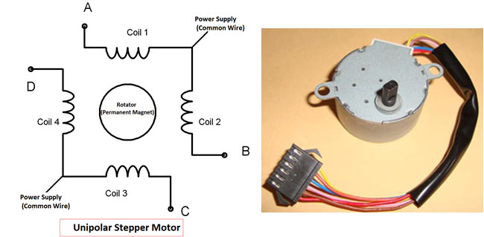

In **Bipolar stepper** motor there is just four wires coming out from two sets of coils, means there are no common wire.

# **Working of a stepper motor**

A stepper motor works on the principle of magnetic attraction and repulsion. The coils of stators are placed on electromagnets which are energized and de-energized by the pulses of the microcontroller which creates magnetic north and south on the stator poles. The rotor is mounted on a permanent magnet having a permanent N and S marked.

[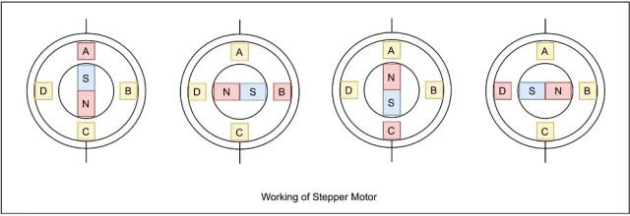](https://i0.wp.com/technobyte.org/wp-content/uploads/2020/05/working.jpg?ssl=1)

The sequence in which the coils are excited to form the poles causes the rotor to attract one pair of stator pole and repel the other causing motion in the shaft and the load connected to it.

# **Interfacing stepper motor to 8051 Microcontroller**

In interfacing with 8051 it is just need to give the 0 and 1 to the four wires of stepper motor according to the above tables depending on which mode we want to run the stepper motor. And rest two wires should be connected to a proper 12v supply (depending on the stepper motor). Here we have used the unipolar stepper motor. We have connected four ends of the coils to the first four pins of port 2 of 8051 through the ULN2003A.

[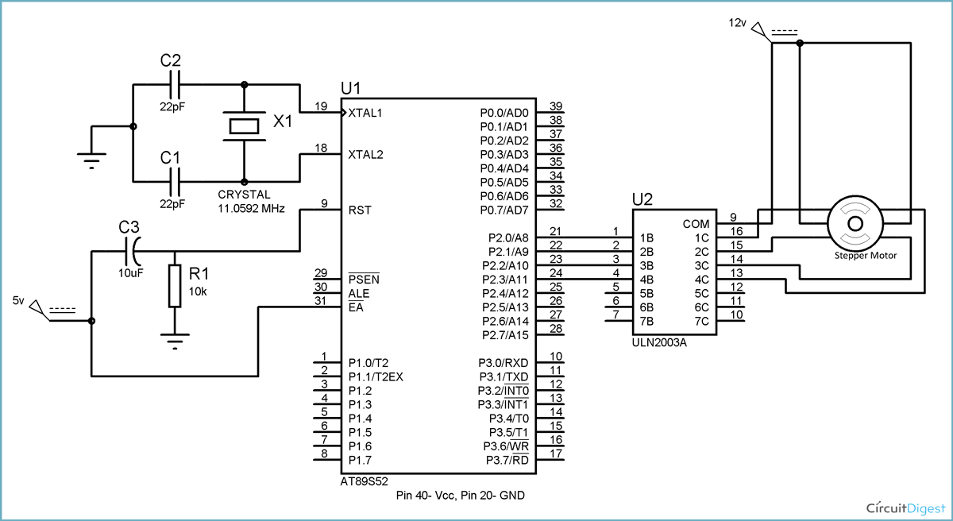](https://circuitdigest.com/fullimage?i=circuitdiagram_mic/8051-stepper-motor-circuit.gif)

8051 doesn’t provide enough current to drive the coils so we need to use a **current driver IC that is ULN2003A**. ULN2003A is the array of seven NPN Darlington transistor pairs. Darlington pair is constructed by connecting two bipolar transistors to achieve high current amplification. In ULN2003A, 7 pins are input pins and 7 pins are output pins, two pins are for Vcc (power supply) and Ground. Here we are using four input and four output pins. We can also use L293D IC in place of ULN2003A for current amplification.

You need to find out four coil wires and two common wires very carefully otherwise motor will not rotate. You can find it out by measuring resistance using multimeter, multimeter won’t show any readings between the wires of two phases. Common wire and the other two wire in the same phase should show the same resistance, and the two end points of the two coils in the same phase will show the twice resistance in compared with resistance between common point and one end point.

We are using Port 2 of 8051 microcontroller to generate high and low pulses and using a current amplifier IC i.e. ULN2003a to amplify the current to drive the stepper motor using the pulse of the microcontroller. On the basis of the way the coils are energized, a Unipolar Stepper motor can be classified into three categories:

Wave Drive Mode

Full Drive Mode

Half Drive Mode

**Wave drive mode**

In this mode only one coil is energized at a time, all the four coils are energized one after the other in a sequence. In terms of power consumption, this mode is a power saver, but the torque produced is less compared to the full drive mode. In the following table, A-B-C-D refers to the stator coils, that are to be energized sequentially in the manner and ‘1’s and ‘0’s refers to ‘HIGH‘ and ‘LOW’ states.

|  |  |  |  |  |  |
| --- | --- | --- | --- | --- | --- |
| **Steps** | **A** | **B** | **C** | **D** | **HEX** |
| **1** | 1 | 0 | 0 | 0 | 0x08 |
| **2** | 0 | 1 | 0 | 0 | 0x04 |
| **3** | 0 | 0 | 1 | 0 | 0x02 |
| **4** | 0 | 0 | 0 | 1 | 0x01 |

**Full Drive mode**

In this mode two coils are energized at a time, i.e. Logic 1 is given to 2 coils at the same time, this results in higher torque, but the power consumption also increases and precision of the stepper motor increases two folds.

|  |  |  |  |  |  |
| --- | --- | --- | --- | --- | --- |
| **Steps** | **A** | **B** | **C** | **D** | **HEX** |
| **1** | 1 | 1 | 0 | 0 | 0x0C |
| **2** | 0 | 1 | 1 | 0 | 0x06 |
| **3** | 0 | 0 | 1 | 1 | 0x03 |
| **4** | 1 | 0 | 0 | 1 | 0x09 |

**Half Drive Mode**

This mode works on the alternate energizing principle, i.e. at one moment only 1 coil is energized, but in the very next moment 2 coils are energized, then again back to 1. This sequence is repeated so as to make the motor more power-efficient while maintaining the high torque and increase the angular rotation of the motor.

|  |  |  |  |  |  |
| --- | --- | --- | --- | --- | --- |
| **Steps** | **A** | **B** | **C** | **D** | **HEX** |
| **1** | 1 | 0 | 0 | 0 | 0x08 |
| **2** | 1 | 1 | 0 | 0 | 0x0C |
| **3** | 0 | 1 | 0 | 0 | 0x04 |
| **4** | 0 | 1 | 1 | 0 | 0x06 |
| **5** | 0 | 0 | 1 | 0 | 0x02 |
| **6** | 0 | 0 | 1 | 1 | 0x03 |
| **7** | 0 | 0 | 0 | 1 | 0x01 |
| **8** | 1 | 0 | 0 | 1 | 0x09 |

# **Stepper Motor Controller Circuit Advantages**

It consumes less power.

It requires low operating voltage

# **Applications of stepper motors**

* Used in Dot Matrix Printer.
* Used in tape drives, floppy disc drives, printers, and electric watches.
* Metal cutting & Metal forming machines.
* Used in textile industries.
* Used in integrated circuits fabrications.